**Project Design Phase**

**Solution Architecture**

|  |  |
| --- | --- |
| Date | 15 February 2025 |
| Team ID | SWTID1741257592149925 |
| Project Name | News app |
| Maximum Marks | 4 Marks |

**Solution Architecture:**

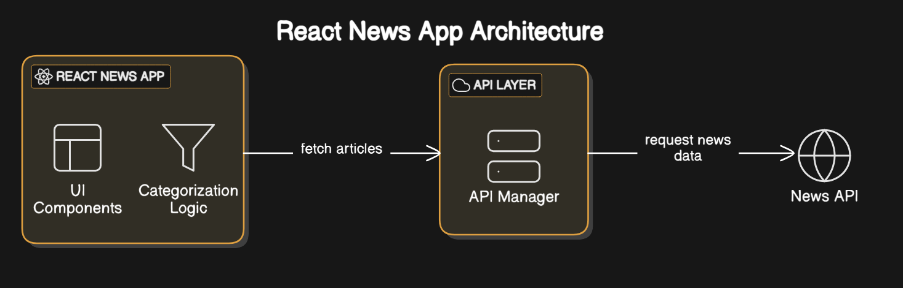

The **React News App Architecture** diagram illustrates the flow of data in a news application built with React. The architecture consists of three main components:

1. **React News App**
   * This is the frontend part of the application that consists of:
     + **UI Components**: Responsible for displaying news articles and user interface elements.
     + **Categorization Logic**: Filters and organizes news articles into different categories.
2. **API Layer**
   * Acts as an intermediary between the frontend and the external news API.
   * Includes an **API Manager**, which handles fetching news articles by making requests to the external API.
3. **News API**
   * The external service that provides real-time news data.
   * The API Manager sends requests to the News API and retrieves news articles for display in the React News App.

### Data Flow:

* The **React News App** requests articles from the **API Layer**.
* The **API Layer** fetches news data from the **News API**.
* The received data is processed by the **API Manager** and then sent back to the React app for display.

This architecture ensures modularity, making it easy to manage API requests separately from the UI while maintaining structured categorization of news content.